# React Component

## Normal Def:

JS Function which return Valid JSX , and its is reusable

function Card({ *id*, *quote*, *author* }) {

    // its destructuring

    return (

        <div *className*="Quote" *key*={*id*}>

            <h1>{*quote*}</h1>

            <p>

                Author : <span>{*author*}</span>

            </p>

        </div>

    );

}

## Real Def: (https://www.youtube.com/watch?v=TUsVCNr7HnY&list=PLfEr2kn3s-brb-vHE-c-QCUq-nFwDYtWu&index=11&t=371s)

React Component is a react element (React.createElement()) in element type is JS function and that function also returns react element (Jsx).

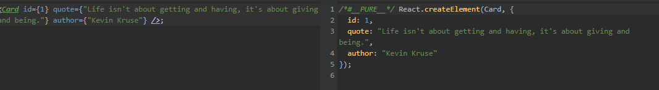

root.render(<*Card* *id*={1} *quote*={"Life isn't about getting and having, it's about giving and being."} *author*={"Kevin Kruse"} />);